INTEGRATED DESIGN PROJECT REPORT

Employee Management System (EMS)



1. **Htoo Myat Kyaing (VR. CEIT-9)**
2. **Htet Mon Oo (V. CEIT-1)**
3. **Kaung Htet (V. CEIT-2)**
4. **Yun Myet Thwe (VR. CEIT-11)**
5. **Thet Htar Kant Kaw (VR.CEIT-10)**
6. **Aye Chan Thu (VR.CEIT-8)**

# CONTENTS

**Chapter**  **Page**

1 Introduction 2

1.1 Objectives of the project 2

1.2 Scope of the proposed system 2

1.3 Overall functions of the system 2

1.4 Advantages of the system 3

1.5 System requirements 4

2 Implementation 9

2.1 Front-end 9

2.2 Embedded system 17

3 Testing 23

4 Conclusion 23

# 

# 1. INTRODUCTION

**1.1 Objectives of the project**

* To reduce paper usage and errors
* To be an office partner that can make frustrating tasks became easy-going tasks
* To reduce time and human efforts
* Foster a Good Business Environment
* Worker retention and employee engagement
* Expanded Accuracy and Delicacy
* Continuous analysis and report management

**1.2 Scope of the proposed system**

EMS is developed with the aim of providing a systematic management of documents using computerized mechanisms. EMS has an Admin panel. It is designed to help the HR department and assigned officers to manage the number of employees of their company. This system provides database activities. Each and every record of employees’ information are maintained in database.

Admin has the full right to know the day-to-day attendance record of employees. The employee does not have a full authority to access the admin panel. It will be exclusive only to the manager and HR department. The system information is limited only inside the organization.

**1.3 Overall functions of the system**

1. Employee information management: It stores and manages essential employee information such as personal details, id number, position and record of attendance.

2. Attendance tracking: It tracks employee attendance by searching name or present and absent as for today. If you want to know the records of particular name for a whole month, go search in records by name.

3. Reporting and Analytics: It generates reports and provides analytics on various HR metrics, helping organizations make data-driven decisions about their workplace.

4. Security and Access control: It maintains data security and controls access to sensitive employee information to protect data privacy and prevent unauthorized access.

**1.4 Advantages of the system**

Employee management system helps organizations manage and streamline their HR processes, such as employee data management, performance tracking and benefits administration. Here are some advantages of using EMS:

* Increased Efficiency - EMS benefits many HR processes, which can save time and reduce errors. For example, employee data can be stored in a centralized database, making it easy to access and update. This can eliminate the need for manual data paper sheets and reduce the risk of errors.
* Ensure Employee Motivation - Motivating employees is one of the best ways to increase productivity and outcomes. With the use of EMS, you can give employees the right salary and provide promotions and rewards for outstanding performance.
* Saves HR Team Time - By using EMS, it helps you save time and resources. The HR department is often responsible for a huge number of administrative tasks including payroll, attendance management, managing training programs, leave request, transfer and terminations of employees.
* Boosted Profitability - EMS is a powerful tool that can help you boost your business productivity and profitability. It allows you to manage the entire lifecycle of employees efficiently.
* Remote access: Many EMS solutions are cloud-based allowing HR professionals to access the system from anywhere, making it valuable especially.
* Improved Decision-Making: The system provides valuable data and analysis, enabling data-driven decision-making related to workforce planning, performance management and talent acquisition.
* Compliance: EMS helps organizations stay compliant with labor laws and regulations by maintaining accurate records, tracking attendance and managing leave policies.

**1.5 System requirements**

For the web application part, the following are required.

**Front-end**

1. *React (Vite) with Typescript*

Utilized React framework along with Vite for efficient and fast development. Integrated Typescript for static typing, enhancing code reliability and maintainability.

1. *Tailwind*

Implemented Tailwind CSS for streamlined styling and layout design, promoting rapid development.

**UI Design**

1. *Mamba UI*

Integrated Mamba UI components for creating a cohesive and visually appealing user interface. Utilized Mamba UI for consistent design elements and enhanced user experience.

1. *Daisy UI*

Incorporated Daisy UI components to complement the overall UI design and ensure a modern look and feel.

**Back-end**

1. *Supabase*

Leveraged Supabase as a back-end as a service (BaaS) to manage employee data and handle authentication.

1. *Node.js*

Utilized Node.js for server-side operations and package management, enhancing the project's scalability and performance.

**Embedded system**

1. C++

All the embedded codes that give instructions to the hardware components are written in C++ language.

1. Hardware

2.1. NodeMCU

Used NodeMCU as controller for other hardware components and connector to Supabase via WiFi.

2.2. MFRC 522

Used to read cards and send card IDs to NodeMCU.

2.3. LEDs

Used for status indications. Red LED is used for hardware or WiFi connection failure. Blue LED is used for ready status. No LED turns on to indicate the process of data uploading to the Supabase and to wait before tapping the next card.

2.4. Buzzer

Used to indicate that the card ID is successfully uploaded to the Supabase.

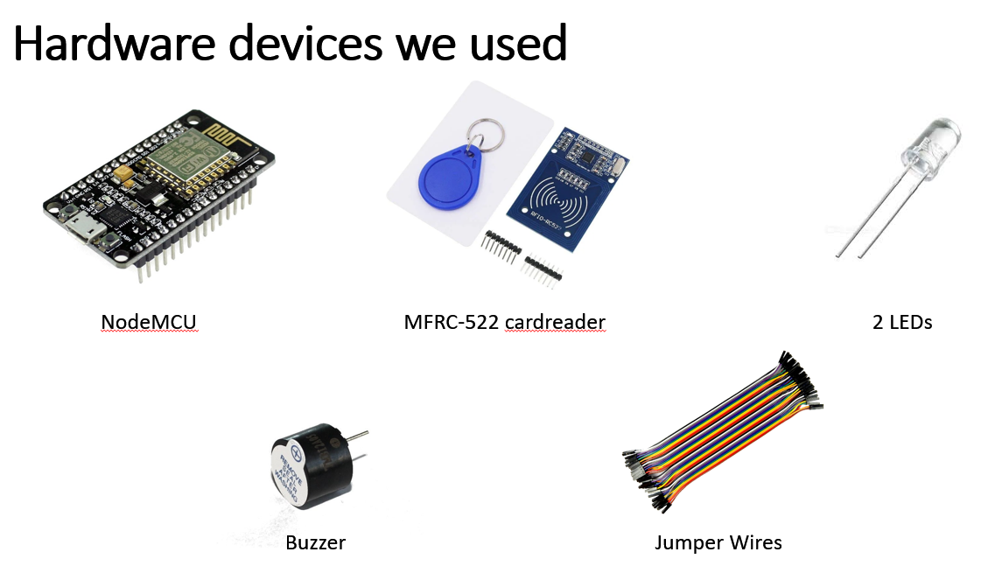

**Miscellaneous**

1. *VS Code*

Used Visual Studio Code (VS Code) as the primary code editor for development, providing a powerful and extensible environment.

1. *Netlify*

Utilized Netlify for hosting the application, ensuring seamless deployment and continuous integration.

1. *Chrome*

Leveraged Google Chrome for debugging and testing purposes, utilizing its powerful developer tools for efficient troubleshooting and optimization.

1. Arduino IDE

Used Arduino IDE to upload command codes from the computer to the microcontroller.

1. Jumper wires

Used to connect hardware components.

1. Cardboard, Single and Double Tape, Glue

Used to build the hardware container.

# 

# 2. IMPLEMENTATION

**2.1 Front-end**

This is a brief explanation of the front-end implementation. For the complete implementation with full explanation: <https://github.com/Htoomyat-Kyaing/integrated-design-project>

This is the login page created with the authentication provided by Supabase. Upon clicking sign-up, the confirmation mail will be delivered to the provided Gmail.

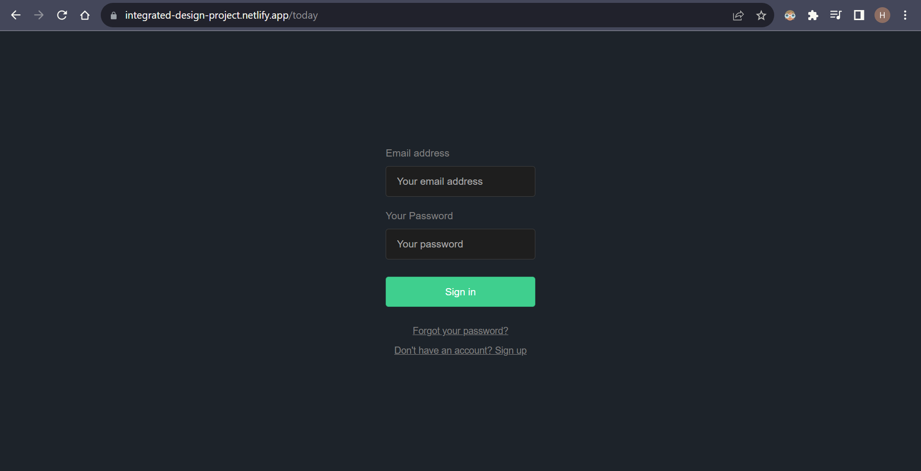

**Login screen (Supabase Auth)**

This is the “Today” page that shows the attendance of employees in real time. Search / Sort functions can be used to check the desired employee quickly. Save records can be used to store records with the current date and time. Reset can be used for changing to default status (absent) for all employees.

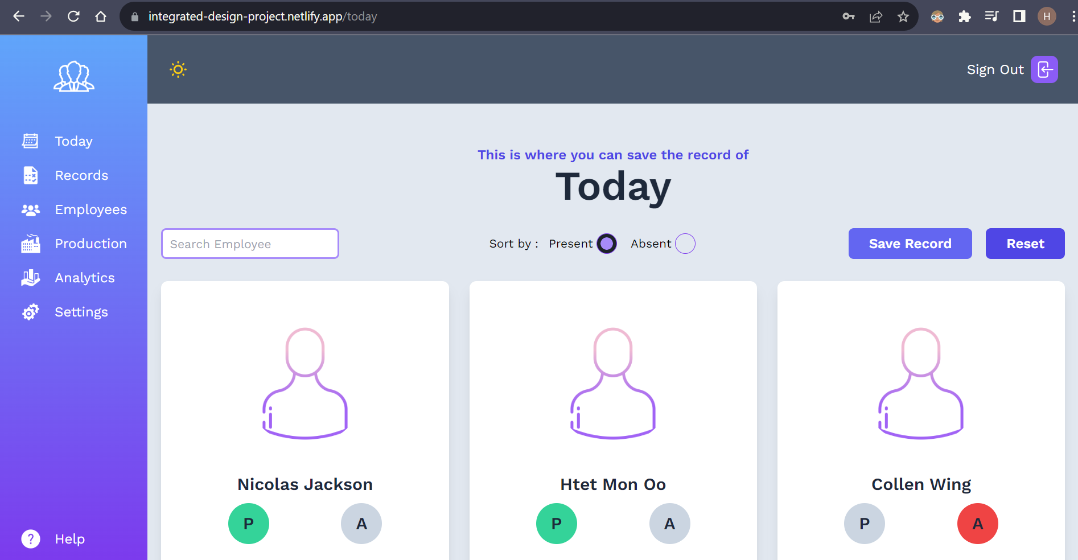

**Sorting (Today)**

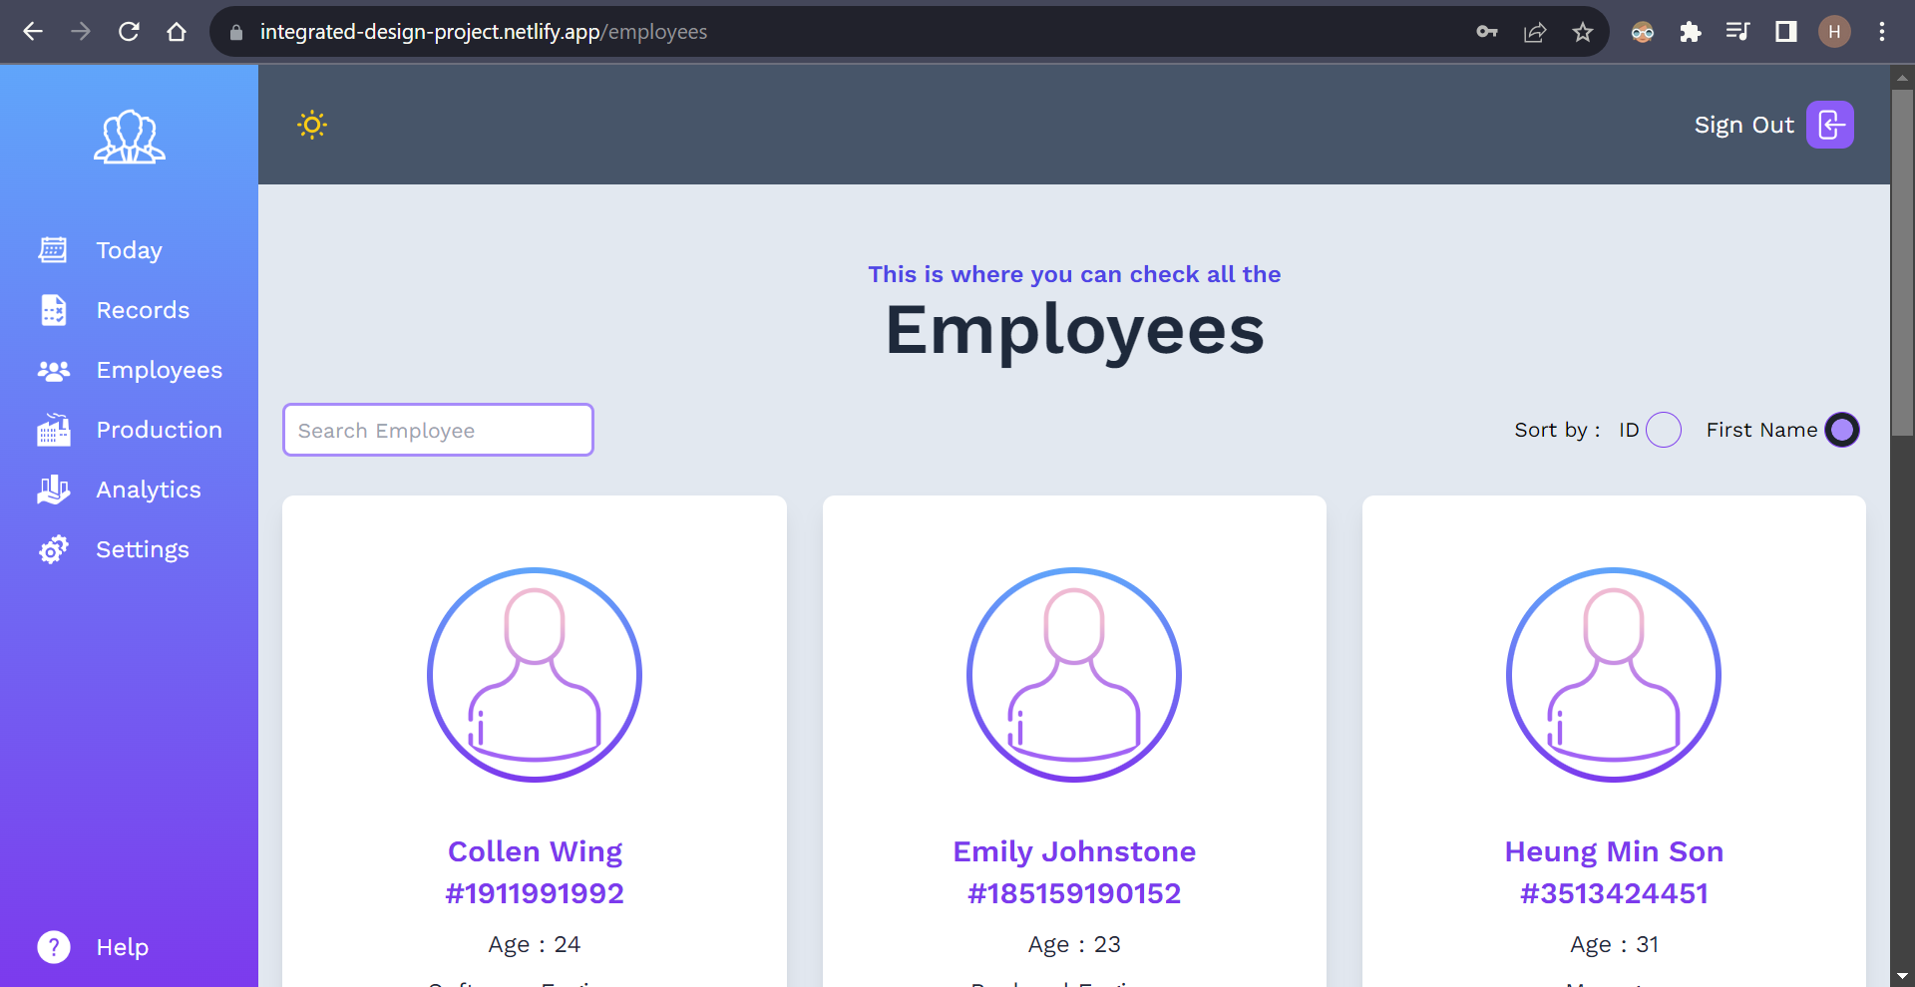

**Sorting (Employees)**

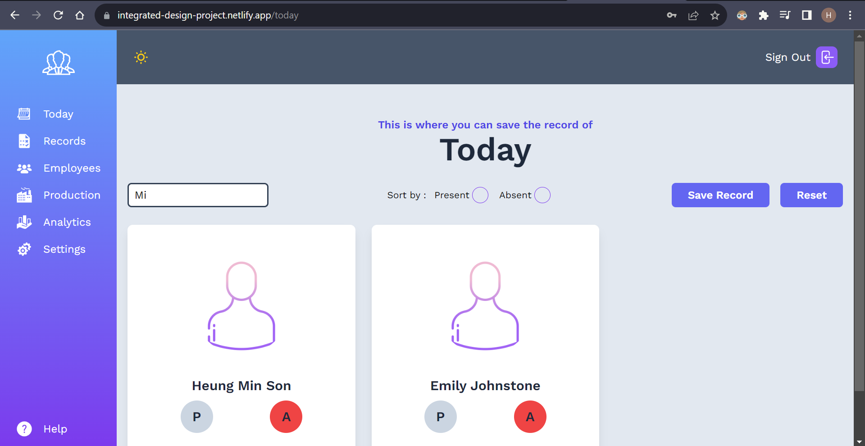

**Searching (Today)**

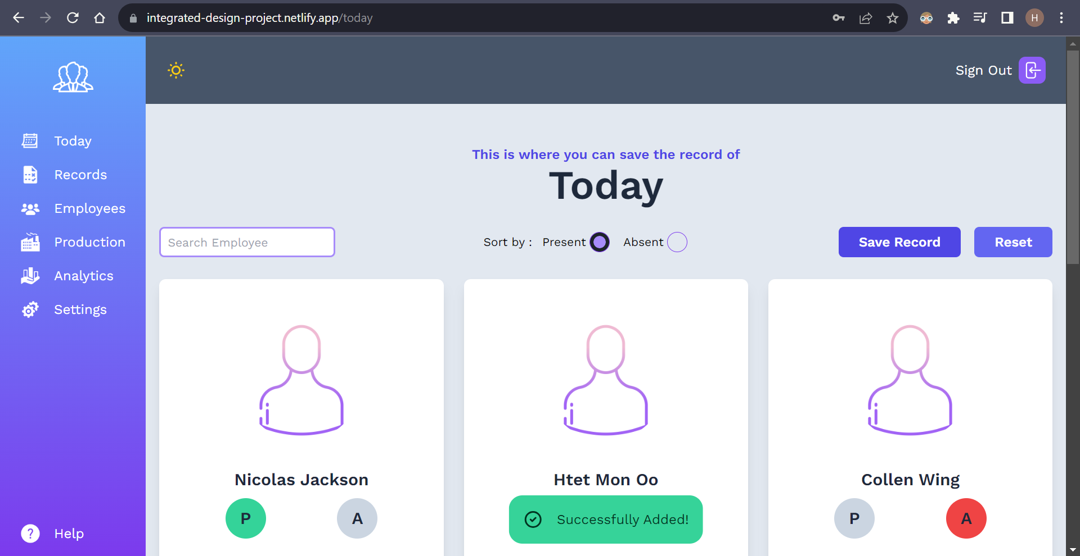

**Today Page (Save record)**

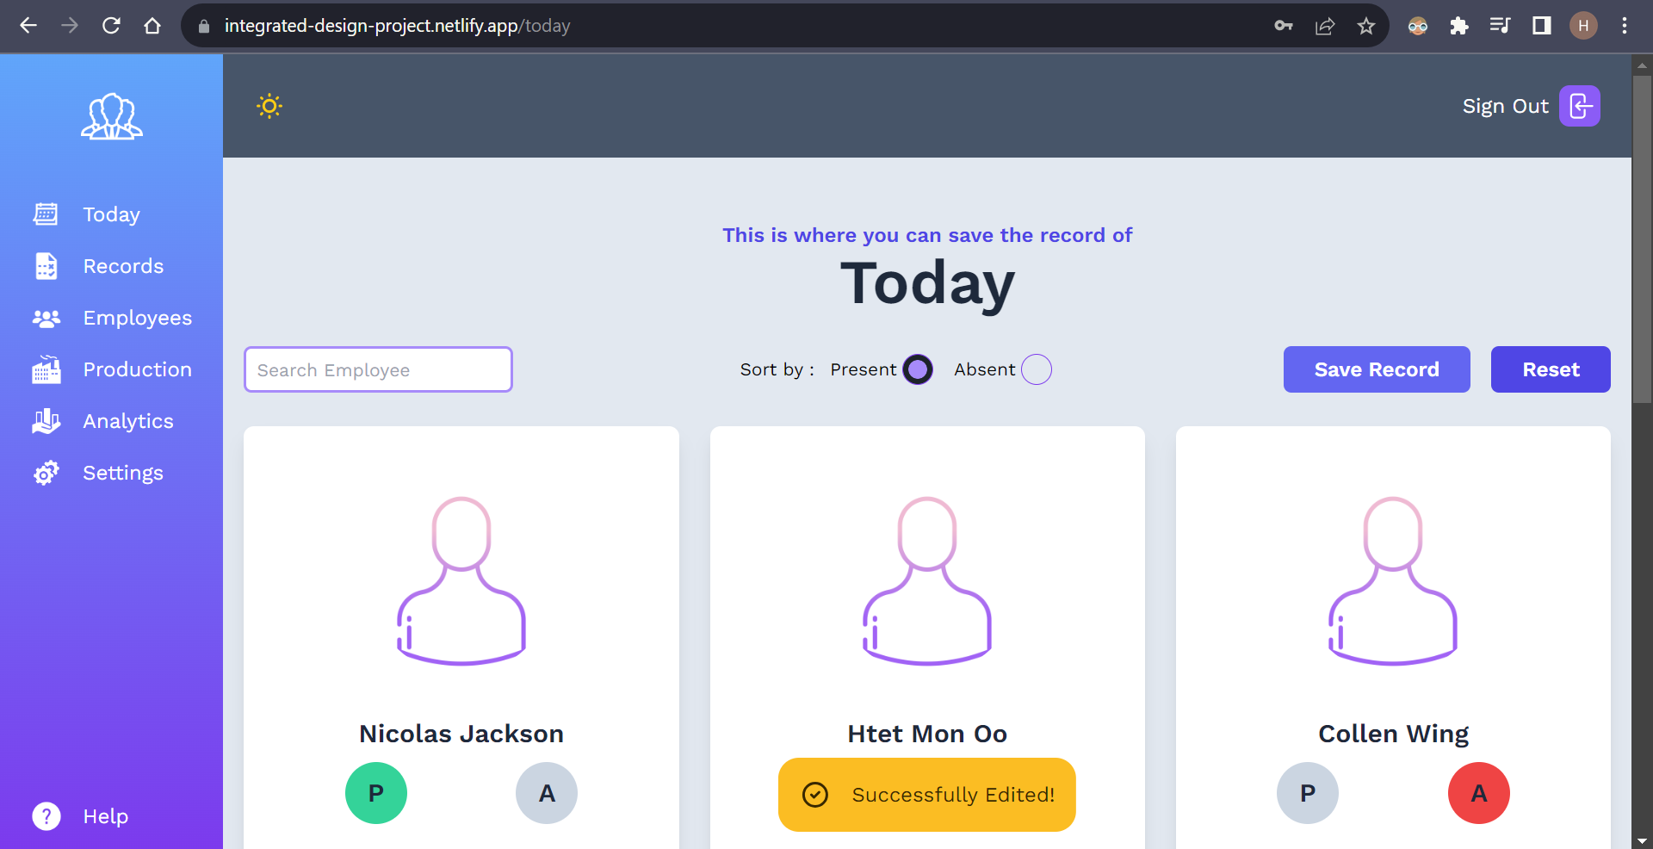

**Today page (Reset)**

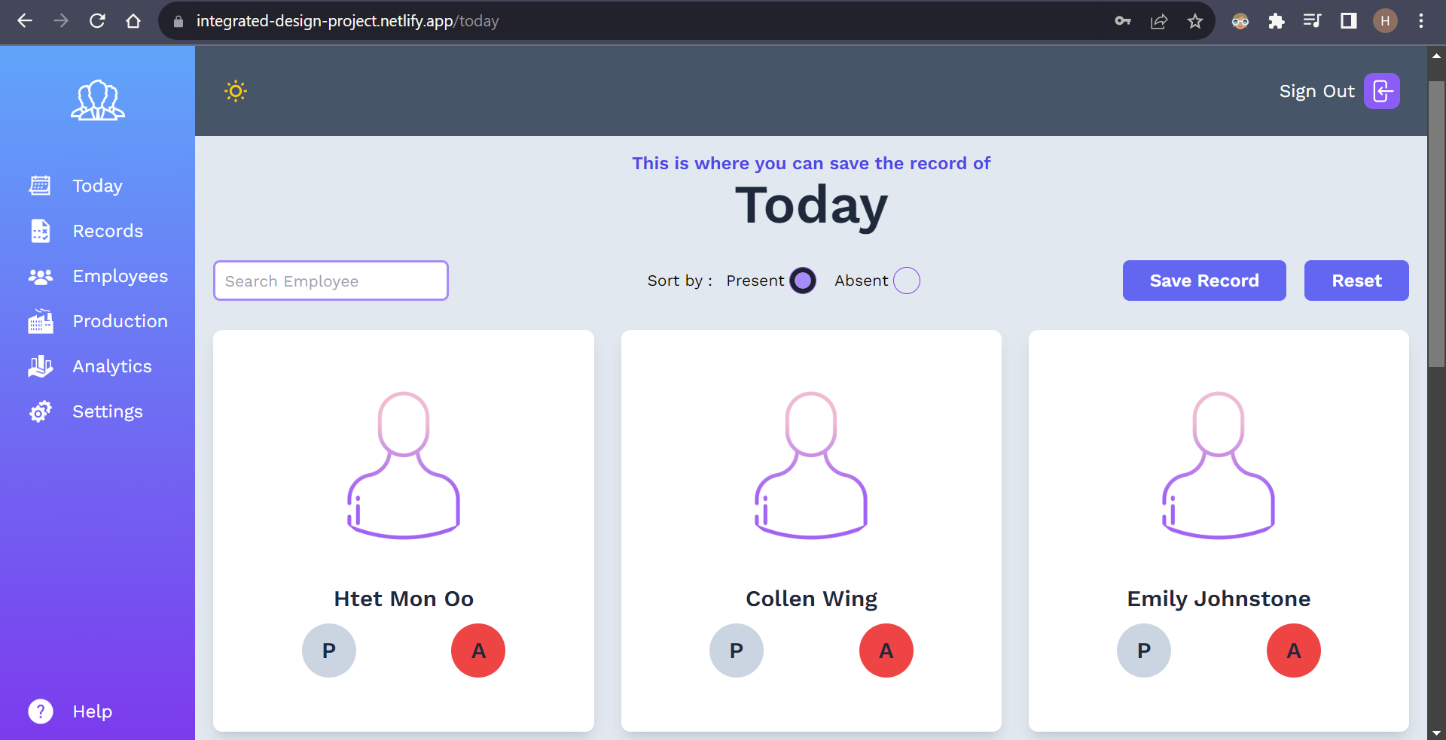

**Today page (After reset)**

This is “Records” page where the records of every employee is saved. Similar to the “Today” page, this page also has a search and sort function for quick navigation.

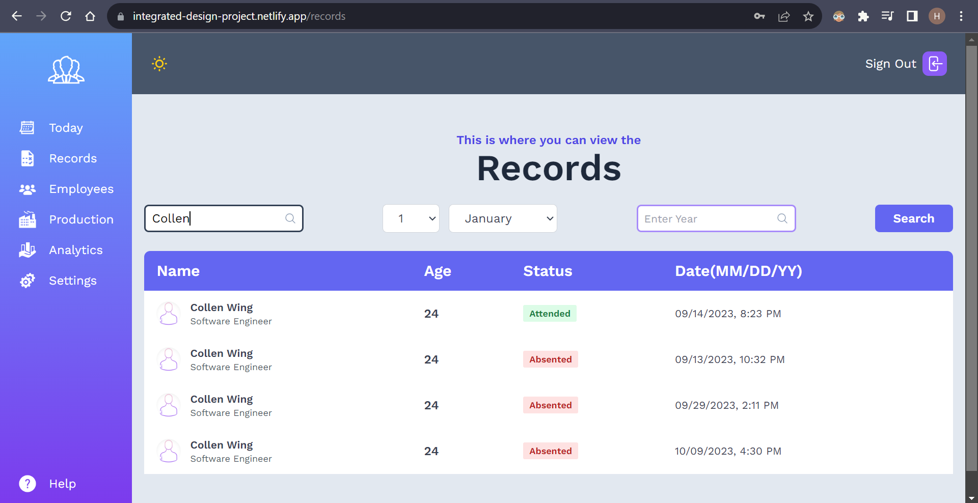

**Searching in general (all related information will be shown)**

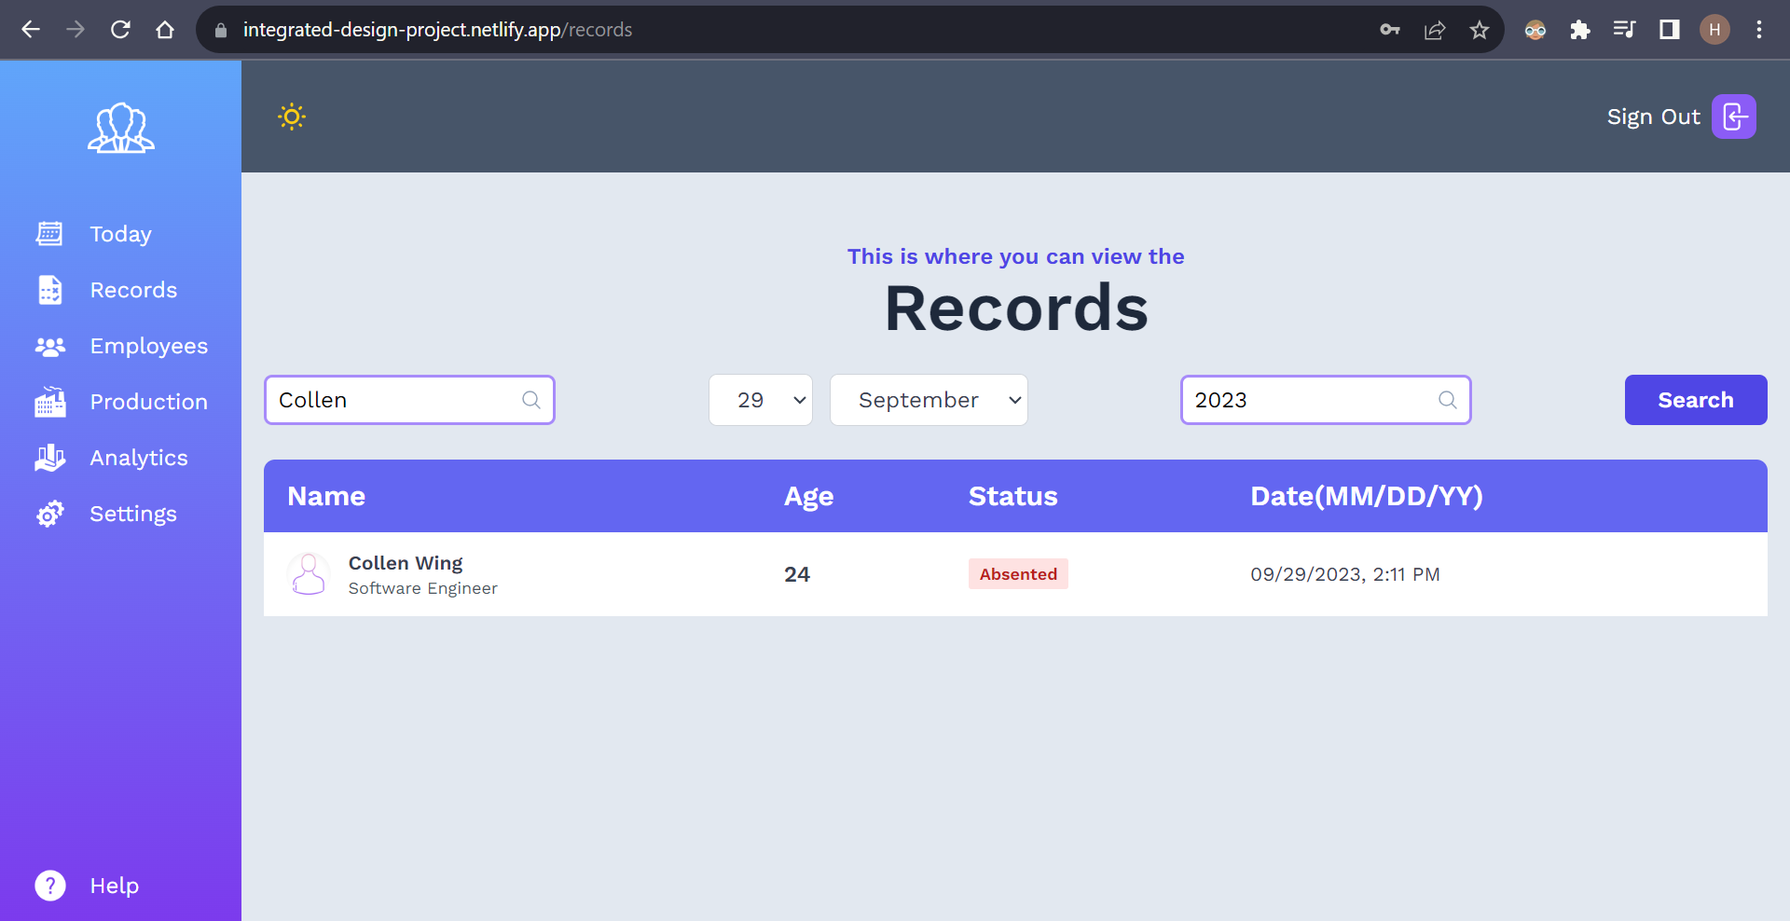

**Searching Collen Wing’s precise record with given date(29/9/2023)**

This is the “Setting” page where you can do CRUD actions directly to the database.

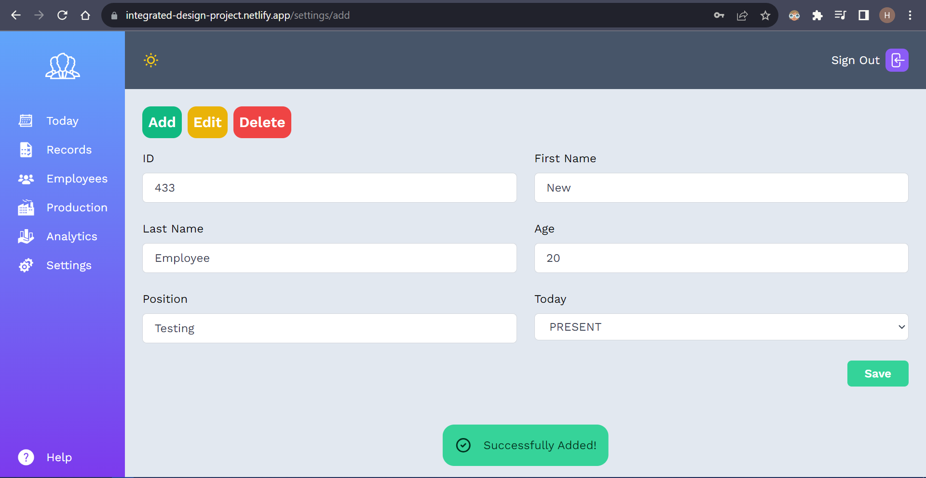

**New employee added**

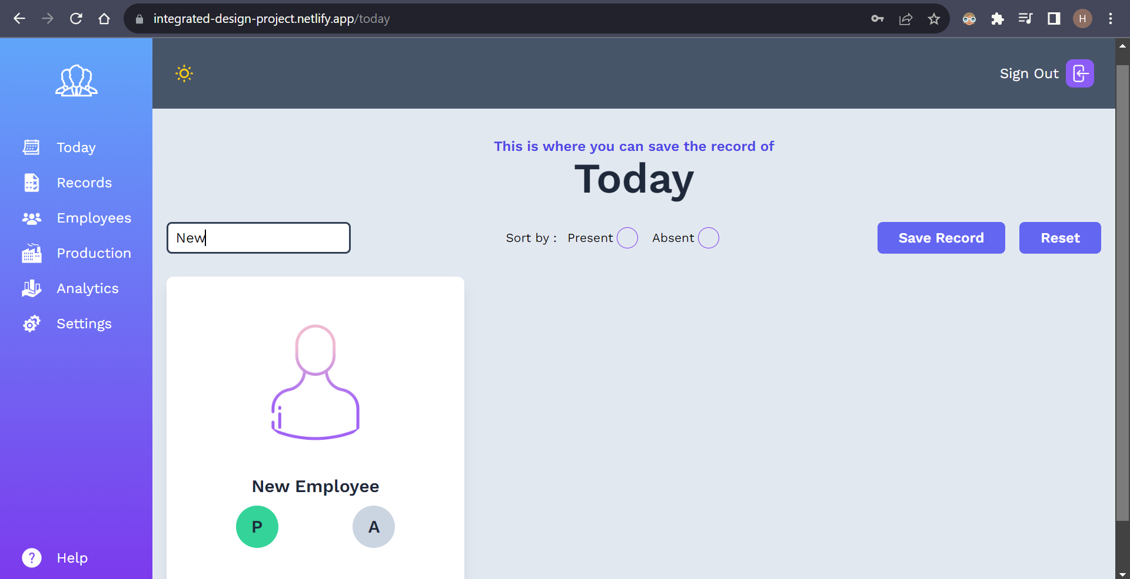

**Checking the newly added employee**

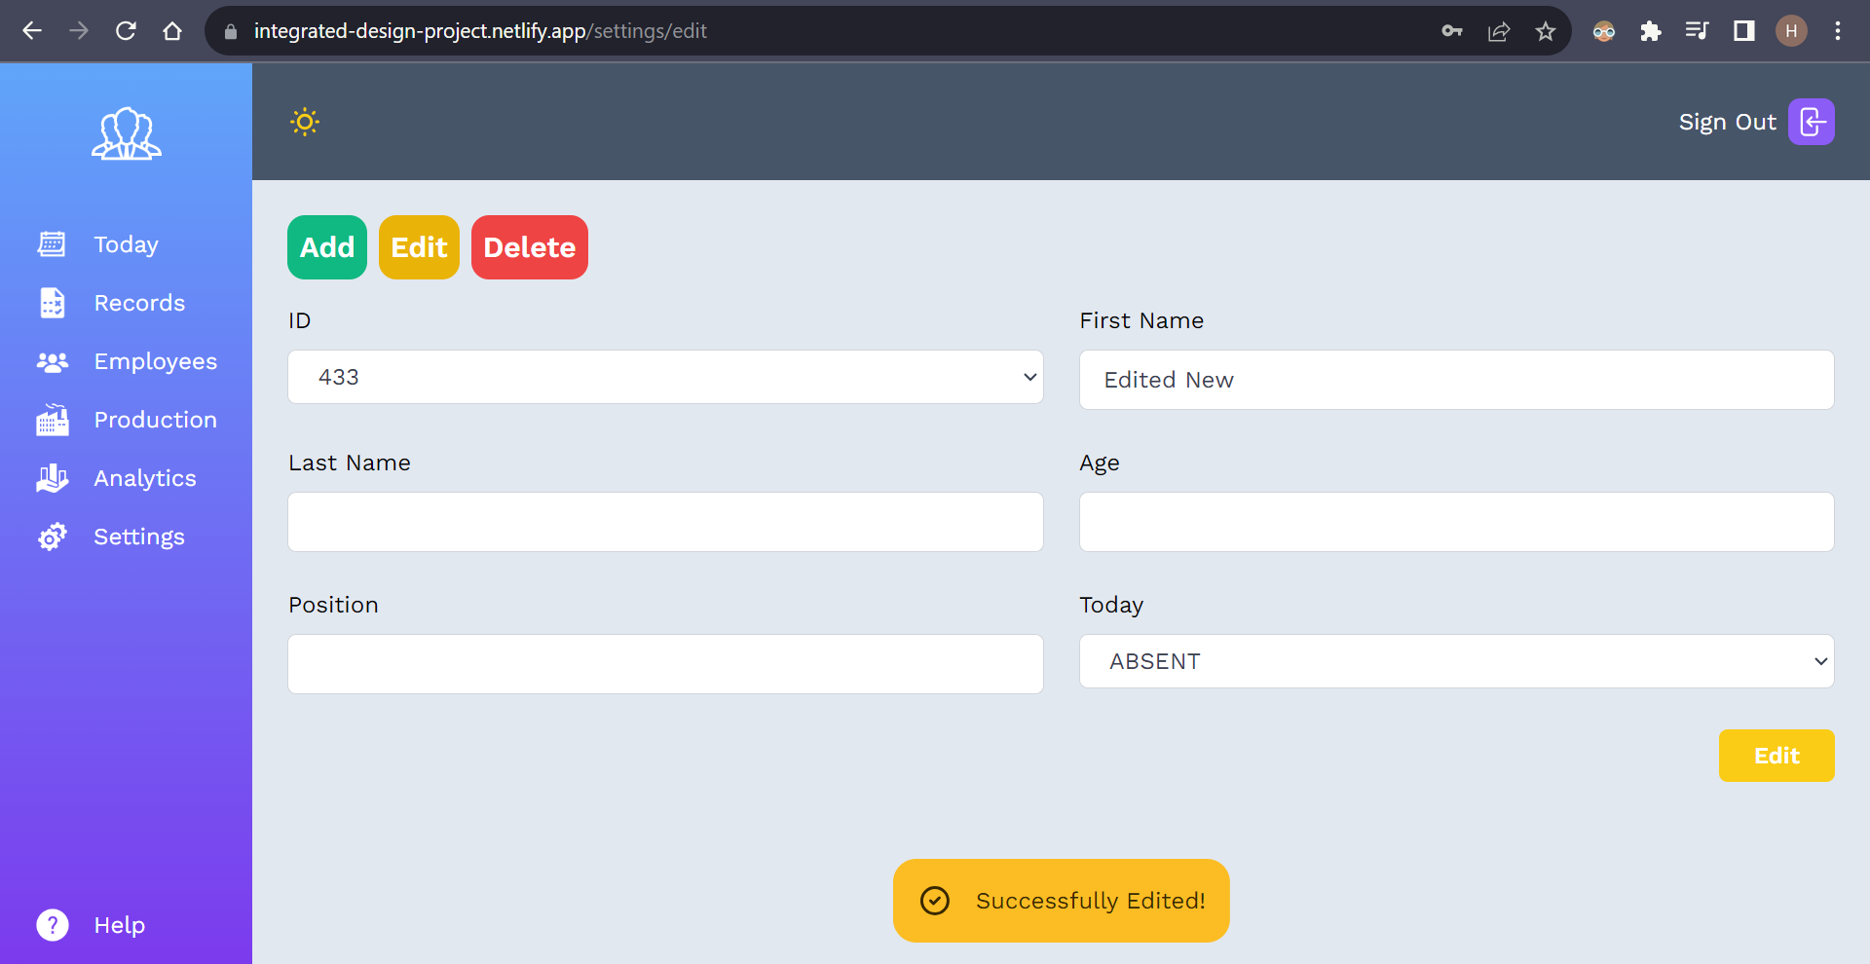

**Updating the new employee**

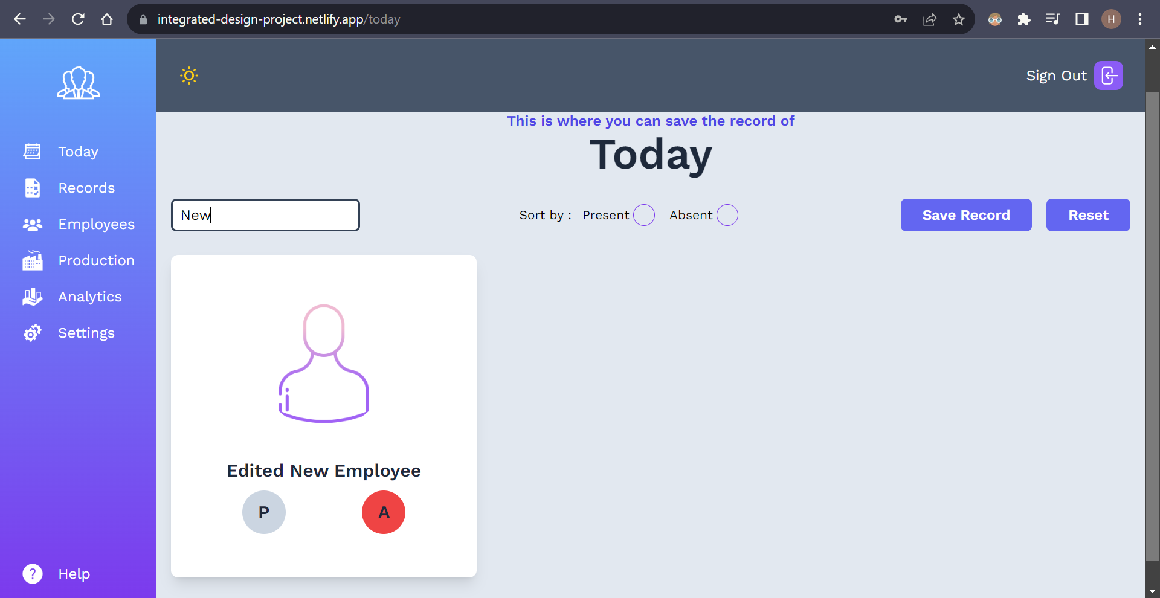

**New employee has been edited**

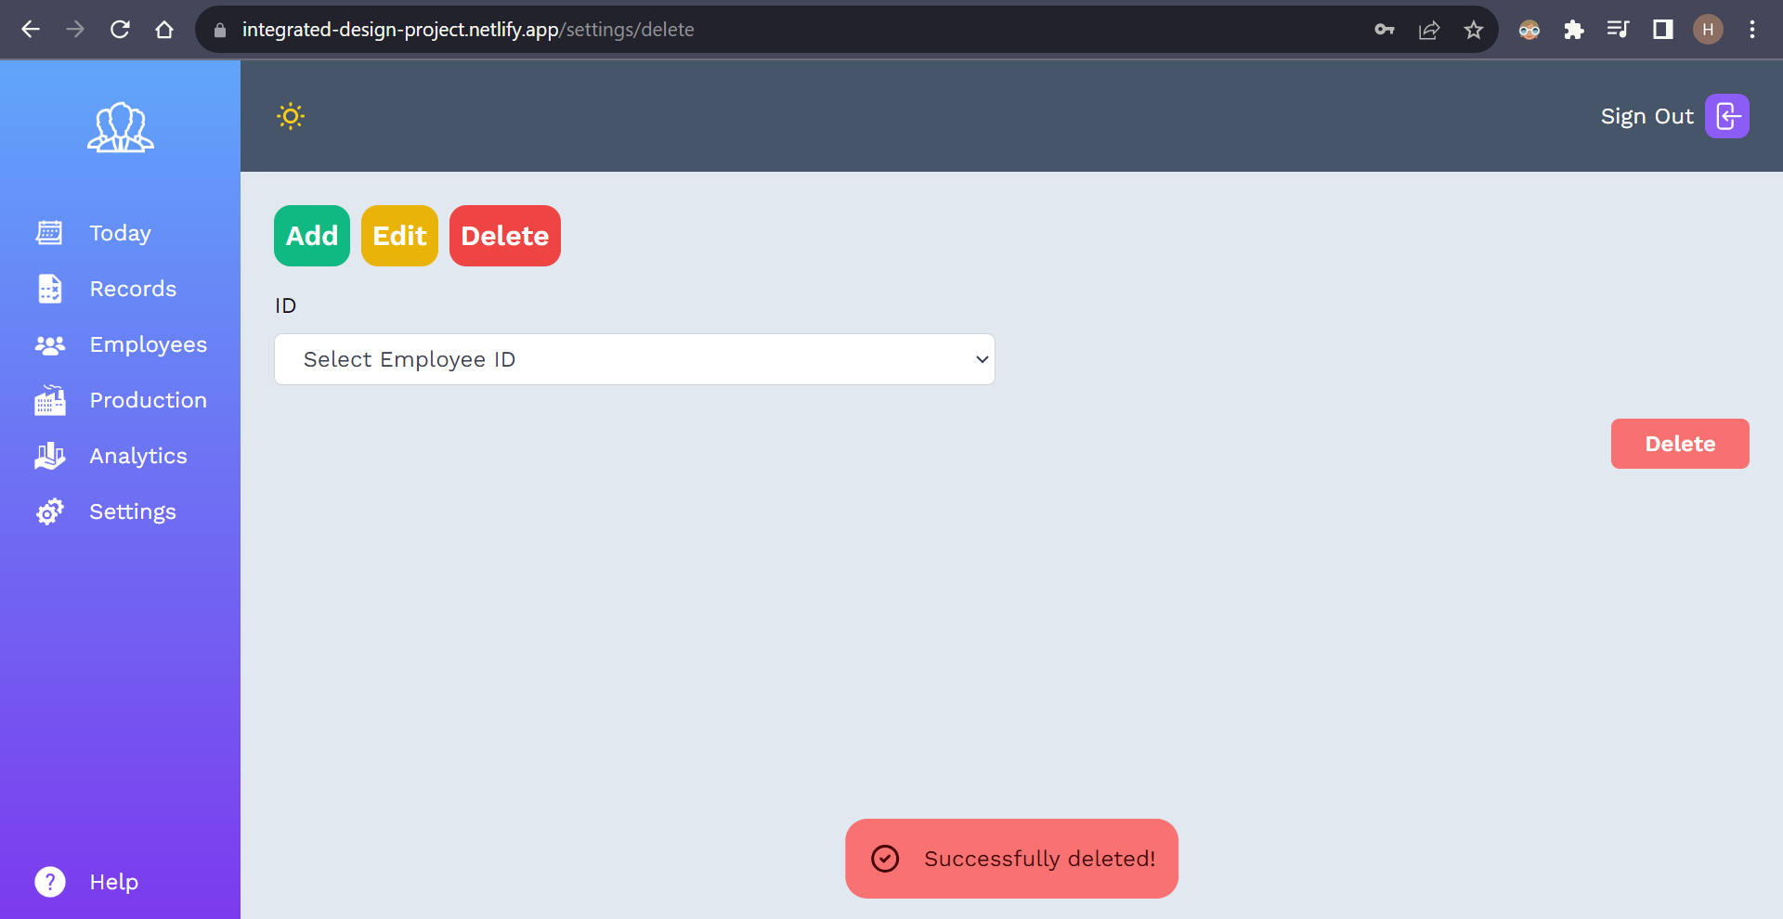

**Removed the new employee**

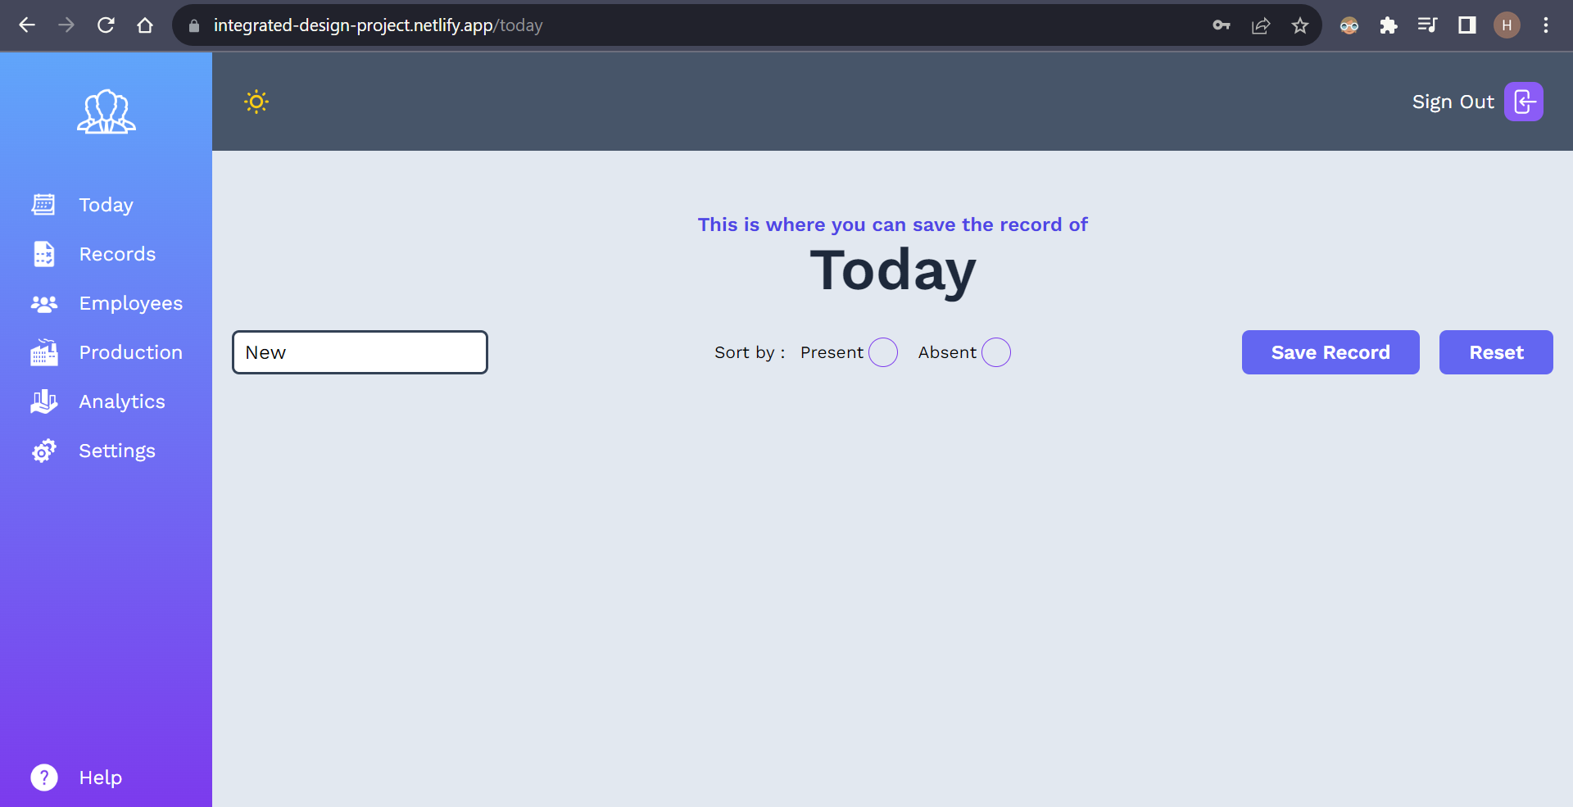

**New employee has been removed**

**2.2 Embedded system**

The embedded system implementation can be subdivided into hardware and software. Connection of hardware components is done as the following circuit diagram.

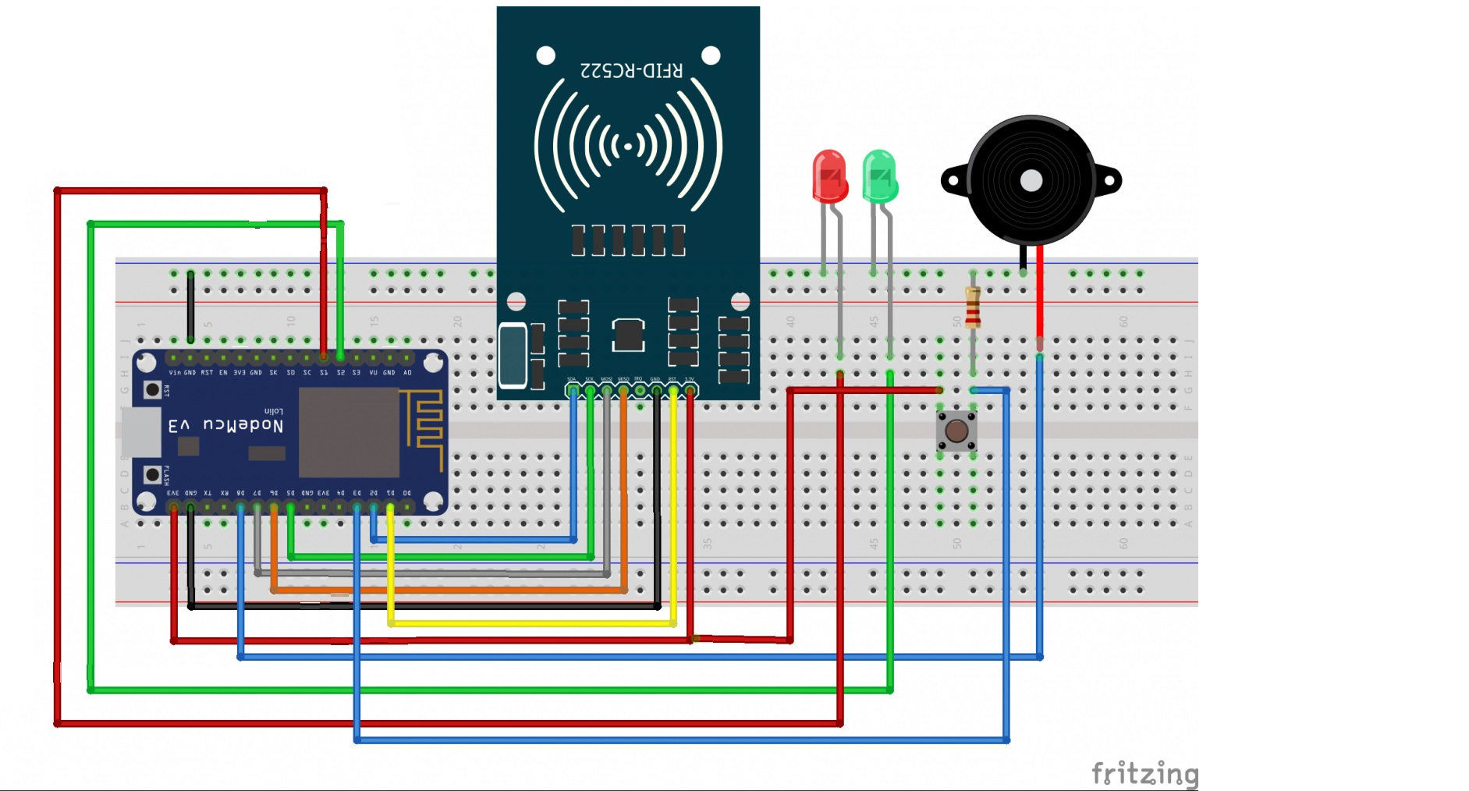

**Circuit diagram**

After the wrie-connection and container building, the result is as follow:

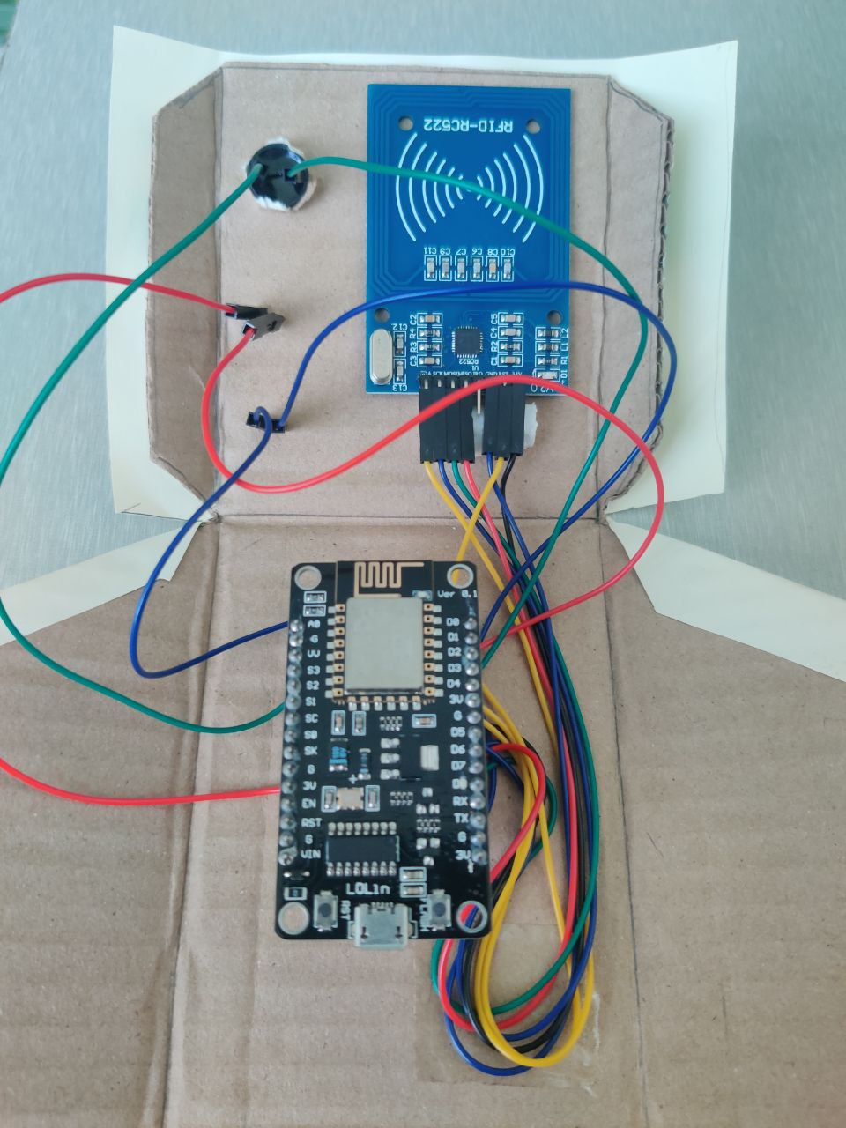 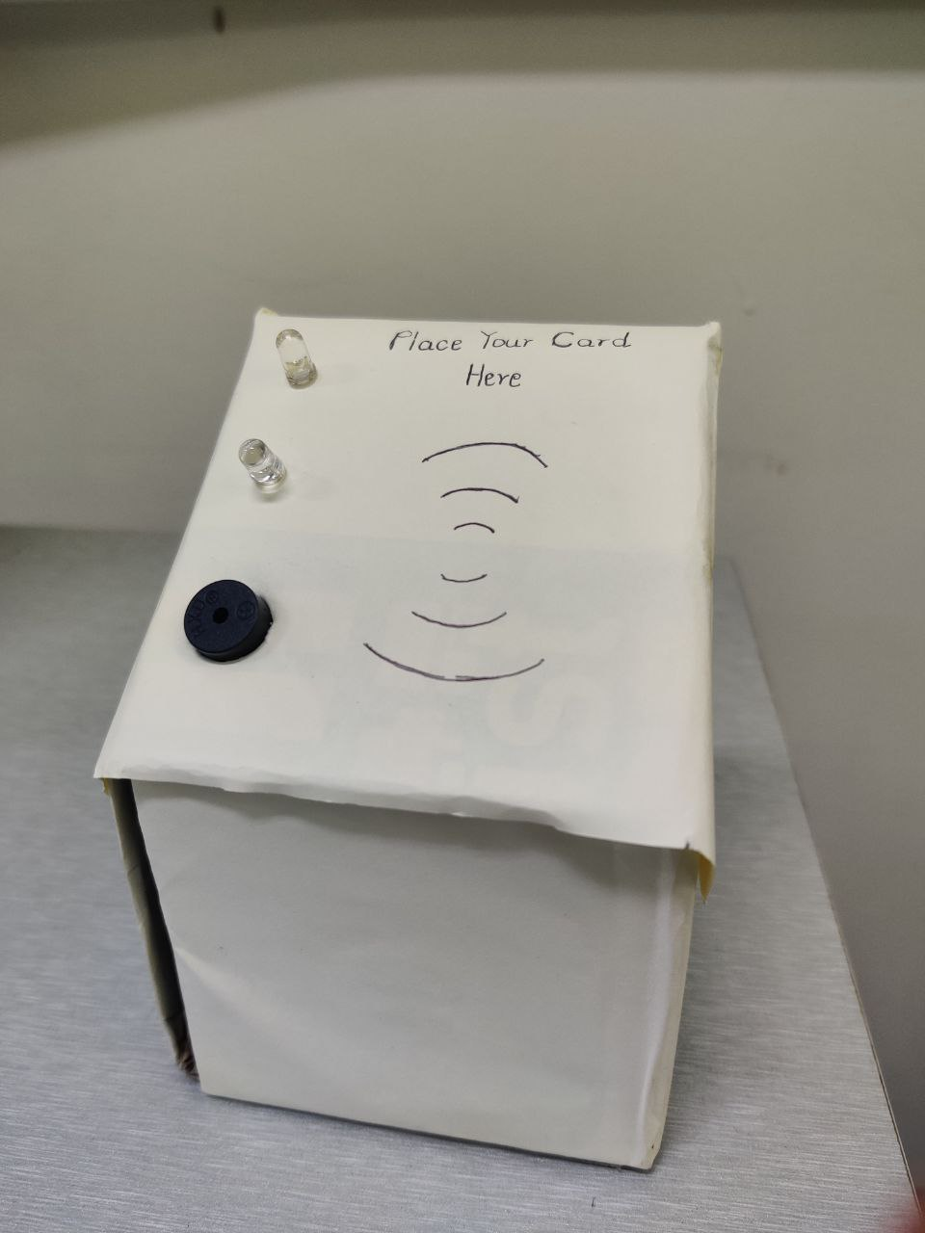

**Inside implementation of container Outside design of container**

The embedded software implementation C++ codes are as follows:

*#include <ESP8266WiFi.h>*

*#include <ESP8266WiFiMulti.h>*

*#include <Supabase.h>*

*#include <Secrets.h>*

*#include <SPI.h>*

*#include <MFRC522.h>*

*Supabase db;*

*const char *supabase_url = SUPABASE_URL;*

*const char *anon_key = SUPABASE_ANON_KEY;*

*// define Wifi credentials from constants stored in Secrets.h*

*const char *ssid = WIFI_SSID;*

*const char *pass = WIFI_PASSWORD;*

*ESP8266WiFiMulti WiFiMulti;*

*constexpr uint8_t RST_PIN = D3; // Configurable, see typical pin layout above*

*constexpr uint8_t SS_PIN = D4; // Configurable, see typical pin layout above*

*MFRC522 rfid(SS_PIN, RST_PIN); // Instance of the class*

*MFRC522::MIFARE_Key key;*

*String tag;*

*constexpr uint8_t led_ok_pin = D1;*

*constexpr uint8_t led_defect_pin= D0;*

*constexpr uint8_t buzz_pin = D2;*

*void setup() {*

*Serial.begin(9600);*

*pinMode(led_ok_pin,OUTPUT);*

*pinMode(led_defect_pin,OUTPUT);*

*pinMode(buzz_pin,OUTPUT);*

*SPI.begin(); // Init SPI bus*

*rfid.PCD_Init(); // Init MFRC522*

*WiFi.mode(WIFI_STA);*

*WiFiMulti.addAP(ssid, pass);*

*Serial.println();*

*Serial.println();*

*Serial.print("Wait for WiFi... ");*

*delay(1000);*

*while (WiFiMulti.run() != WL_CONNECTED)*

*{*

*Serial.println(".");*

*digitalWrite(led_defect_pin,HIGH);*

*delay(500);*

*}*

*Serial.println("");*

*Serial.println("WiFi connected");*

*digitalWrite(led_defect_pin,LOW);*

*Serial.println("IP address: ");*

*Serial.println(WiFi.localIP());*

*delay(500);*

*}*

*void loop() {*

*while (WiFiMulti.run() == WL_CONNECTED)*

*{*

*bool result=rfid.PCD_PerformSelfTest();*

*if(result)*

*{*

*Serial.println("Card reader OK");*

*digitalWrite(led_ok_pin,HIGH);*

*digitalWrite(led_defect_pin,LOW);*

*if ( !rfid.PICC_IsNewCardPresent())*

*return;*

*if (rfid.PICC_ReadCardSerial()) {*

*for (byte i = 0; i < 4; i++) {*

*tag += rfid.uid.uidByte[i];*

*}*

*Serial.println(tag);*

*updatetoSupabase(tag);*

*tag = "";*

*rfid.PICC_HaltA();*

*rfid.PCD_StopCrypto1();*

*}*

*digitalWrite(led_ok_pin,LOW);*

*delay(2000);*

*}*

*else*

*{*

*Serial.println("DEFECT or UNKNOWN");*

*digitalWrite(led_defect_pin,HIGH);*

*digitalWrite(led_ok_pin,LOW);*

*delay(2000);*

*}*

*}*

*WiFi.mode(WIFI_STA);*

*WiFiMulti.addAP(ssid, pass);*

*digitalWrite(led_defect_pin,HIGH);*

*digitalWrite(led_ok_pin,LOW);*

*delay(500);*

*}*

*void updatetoSupabase(String rfid)*

*{*

*// Create Supabase Connection*

*db.begin(supabase_url, anon_key);*

*Serial.println("Supabase URL Worked");*

*// Put your target table here*

*String table = "employees";*

*String JSON = "{ \"today\" : \"TRUE\" }";*

*bool upsert = false;*

*int code = db.update(table).eq("id",rfid).doUpdate(JSON);*

*Serial.println(code);*

*if (code==204)*

*{*

*digitalWrite(led_ok_pin,LOW);*

*digitalWrite(led_defect_pin,LOW);*

*digitalWrite(buzz_pin,HIGH);*

*delay(500);*

*digitalWrite(buzz_pin,LOW);*

*delay(2000);*

*}*

*}*

The embedded system consists of two parts: data (ID) acquisition and data (ID) uploading. The data acquisition follows these simple steps.

Once powered on the nodeMCU, it first tries to connect to the Wi-Fi network. If the connection to the Wi-Fi network fails, the red LED will be turned on and nodMCU tries to reconnect the Wi-Fi network.

When Wi-Fi is connected successfully, it checks whether the MFRC 522 (card reader) is properly working. If the card reader is not connected properly, the red LED will continue to lit. Otherwise, the blue LED will be turned on, signaling that the card reader is ready to read cards.

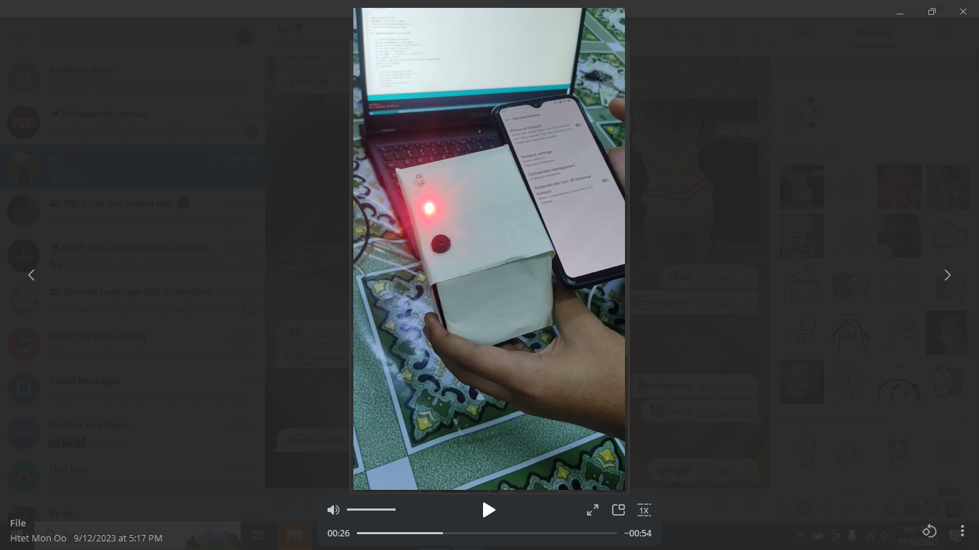 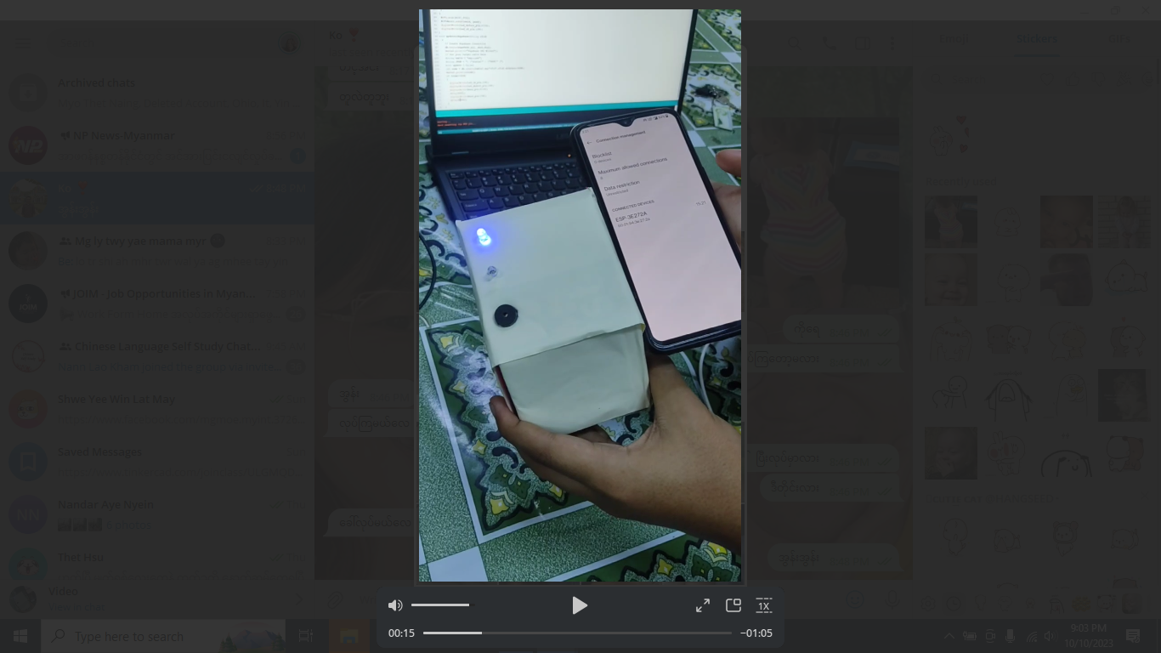

**Red LED on Blue LED on**

When a card is tapped on the card reader, it gets the unique ID of the card and sends it to the nodeMCU. In the meantime, the blue led is turned off to show that the card reader is processing the ID number.

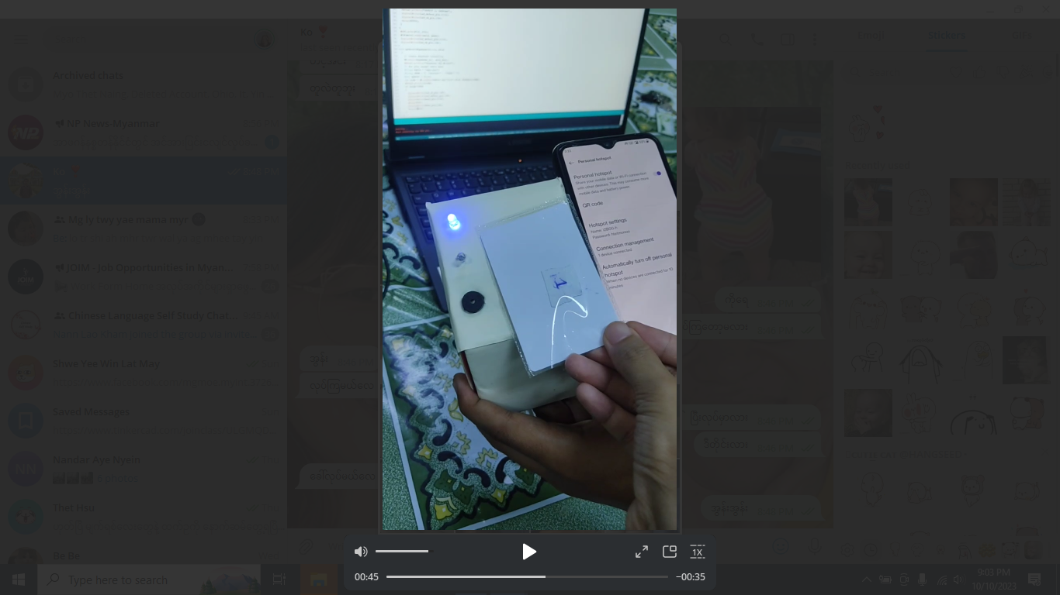 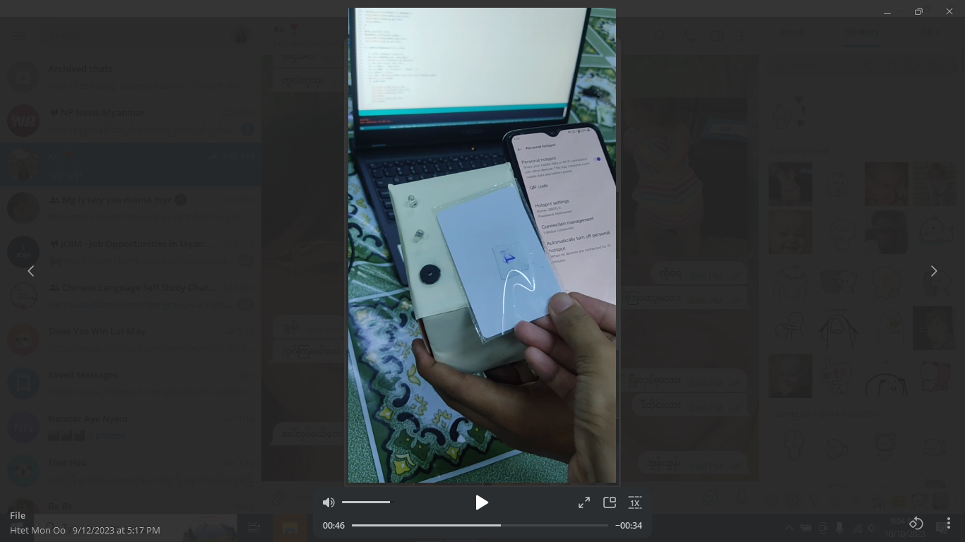

**Tapping the card to the card reader Blue LED off**

After this step, data uploading begins. The node MCU signs in to the Supabase account with URL and the anonymous key and uploads the card ID to the related table in Supabase.

If the card ID is successfully uploaded, the buzzer will be turned on for 2 seconds. Either the uploading is successful or not, when the uploading is finished, the blued led will lit again and the card reader is ready to read cards again. The working steps are described in the following sequence diagram.

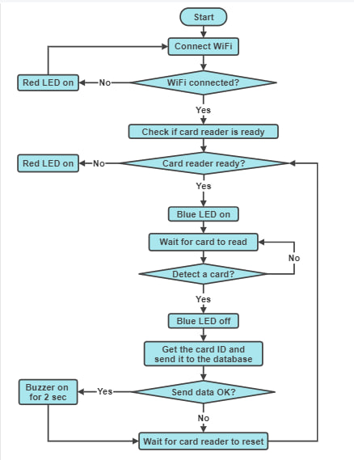

**Sequence diagram of embedded system**

# 

# 3. TESTING

The front-end and embedded system are developed, implemented, and tested separately first. When it is certain that all different components are working properly, the components are connected together and tested until the desired result is obtained.

# 4. CONCLUSION

In conclusion, the completion of the Employee Management System (EMS) project marks a significant achievement as we have successfully met all the defined project objectives. The project embodies a leap towards modernizing employee management processes, reducing reliance on traditional paperwork, and providing a comprehensive digital solution. However, an important lesson learned from this project is the potential challenges arising from the integration of diverse front-end technologies. The presence of different tech stacks led to occasional discrepancies where some pages didn't function optimally. This highlights the importance of a streamlined and standardized tech stack to ensure seamless collaboration and compatibility across the application. Looking ahead, the project is positioned for expansion and further enhancements. Future iterations could involve refining the user experience, expanding functionalities, and addressing any identified limitations. By leveraging a consistent tech stack throughout the front-end, we can overcome the challenges encountered in this project and provide a more cohesive and integrated application. Ultimately, the Employee Management System (EMS) offers a modern and efficient alternative to traditional paper-based employee management. With its intuitive user interface, streamlined processes, and robust functionality, the system is poised to revolutionize employee management, enhancing productivity and organizational efficiency for businesses transitioning towards digital solutions. The successful accomplishment of this project paves the way for future endeavors in creating advanced systems that cater to the evolving needs of the workforce and propel businesses towards a technologically empowered future.